Parsers
The easy way to remember the working of parsers (LL, LR) think of how you would do it naturally.
In LL, u try to choose productions. You write them. (Expanding in stack). Match. Move ahead (pop in stack).

In LR u do reduction. U move ahead if no reduction possible (shift), and if possible do reduce (reduction).

Action, GOTO, rerun:

If in a LR item if we have E→alpha., LA then we reduce alpha in stack by E if the next character is one of LA.

On doing reduction, we go to appropriate state by rerunning the DFA so that we get in a state that says, “that we have seen input, that ends (right) with string derivable from E”.

GOTO helps us getting in appropriate place when rerunning.

ACTION helps when we do shifting.

LALR(1), LR(1)
https://en.wikipedia.org/wiki/LL_grammar

https://www.youtube.com/watch?v=mc6g-i84VjQ&list=PLde1J4XOn2z0i6fc39dI6OWjEoNuaFglI&index=15

https://www.youtube.com/watch?v=dwb32J9rNMY&list=PLxP0p--aBHmJKqrSFBatFypgviqGRxMKO&index=27

LALR is construted by LR(1) by comibing have same productions (lookahead may be different, combine them). We get same states (expect for lookaheads) as in LR(0), SLR(0).

Comparison of different parsers.
https://gateoverflow.in/37184/lalr-vs-clr-vs-slr
If there is no RR conflict in CLR(1) then there may or may not be RR conflict in LALR(1)
- If there is no SR conflict in CLR(1) then there is no SR conflicts in LALR(1)
- Number of states in SLR(1) and LALR(1) are same, goto moves are identical ,shift moves are identical, reduce moves may different else point 1 will never be satisfied.
- LALR(1) and CLR(1) both uses LR(1) items.
- LR(0) and SLR(1) both uses LR(0) items.

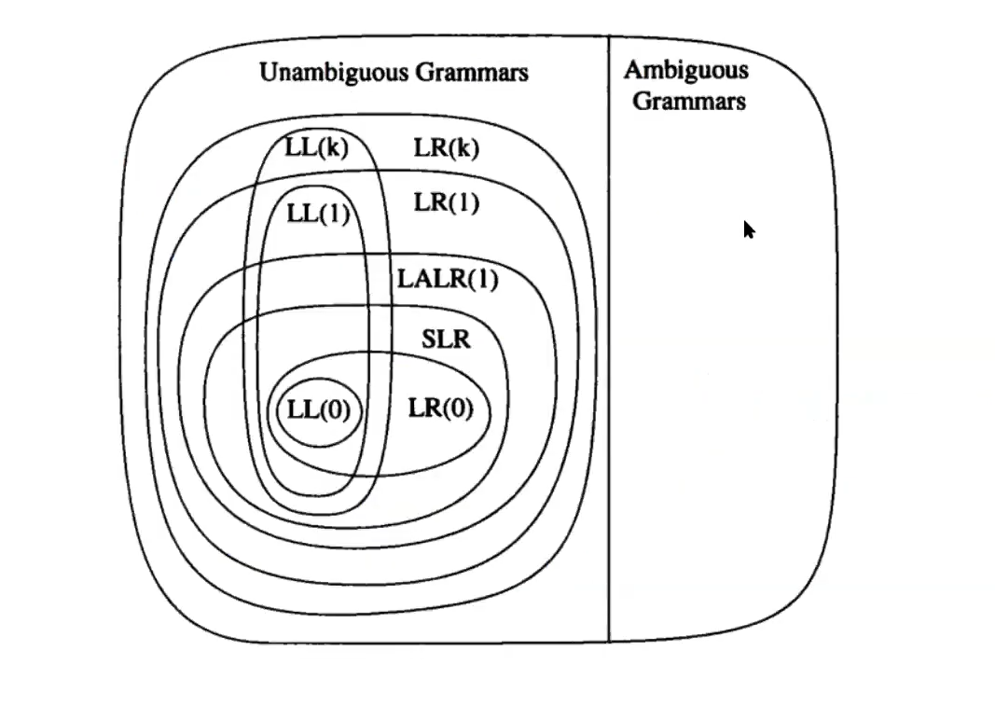
In general LL(k) < LR(k) for any k = 0, 1, … k.

Checking for grammar
https://gateoverflow.in/169567/finding-type-of-grammar-ll-1-or-lr-0-or-clr-1-or-lalr-1

VIABLE PREFIX, HANDLE, STACK TOP.

LL(1), stack top = the current T/NT in focus.
Stack content = from that focus current leafs of the parse tree (may have T/NT).

